EQULIBRIUM

INTRO:

Collision Theory (Gas Phase)- describes what is happening during a chemical reaction. For the reaction to occur, the particles must have sufficient kinetic energy (Activation energy) and correct orientation.

RATE OF REACTION= number of successful collisions per unit time

Rate of reaction changed by:

* Concentration: Increase in substance, more chance of collisions
* Pressure: Increase, in pressure, means less space and concentration per unit space is increase causing more collisions
* Temperature: temperature increase, causes an average kinetic energy increase in material (not all molecules will be same kinetic energy). Therefore more particles have sufficient energy and an increase in this energy also causes the molecules to have a higher velocity, causing more frequent and successful collisions.

With reversible reactions, a change in temperature will affect both reactions as the proportion of particles with enough energy for each reaction to proceed increases. The extent of the changes relative to each other will determine the relative amount of products and reactants, and therefore the equilibrium constant.

* Surface Area: If surface area is increase of the material, there will be more particles on the surface available for collision.
* Catalysts: Catalysts provide an alternative, easier pathway for the reaction. Activation energy is lowered and more particles are able to achieve this level of energy, allowing more successful collisions.

CLOSED SYSTEM: All matter in a reaction is contained in a certain space. Energy can still enter/leave.

OPEN SYSTEM: When matter can enter or be lost from the system, including energy.

Physical change: NO new substances. The physical properties change, this can include a change in state. Reversible

Chemical Change: Reactants produce new substance with different physical and chemical properties from the original substances. The atoms re-arrange and form products. Can be reversible, but not always.

Both Physical and Chemical changes usually cause an observable change.

REVERSIBLE REACTIONS (↔): where reactants form products and the products form reactants simultaneously. For a reaction to be reversible, the activation energy of both the forward and reverse reaction need to be low enough that a sufficient amount of particles will have enough energy for successful collisions. There will never be a “completion” with a reversible reaction, rather it will reach a state of DYNAMIC EQUILIBRIUM.

Dynamic Equilibrium is a state that is reached when the amount (concentration) of reactants and products remain constant even though the forward and reverse reactions are still constantly occurring. This is an example of a steady state system. Steady state systems have constant properties.

When reactants are initially placed in a system, their concentration will be higher than the products, but as the reaction goes on, the concentration of the reactants will decrease and the products concentration will increase, until equilibrium is achieved (the concentrations are very rarely equal). Equilibrium occurs when the RATE of the two reactions is the same.

A CHEMICAL SYSTEM WILL REACH EQUILIBRIUM IF:

* Closed System
* Involved reversible equilibrium/ reaction

AT EQUILIBRIUM:

* Rate of forward reactions is same as reverse
* Concentrations remain constant
* Macroscopic properties will remain the same EXAMPLE: colour and mass of solid.

GRAPHING:

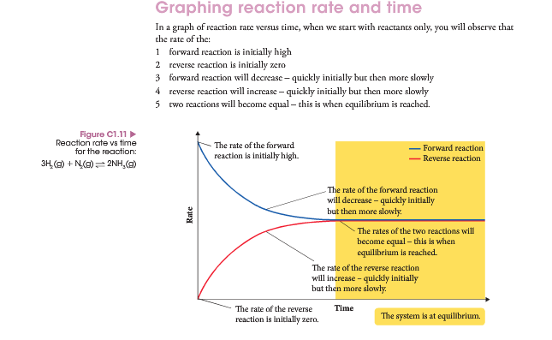Reaction Rate Vs. Time

Concentration Vs. Time

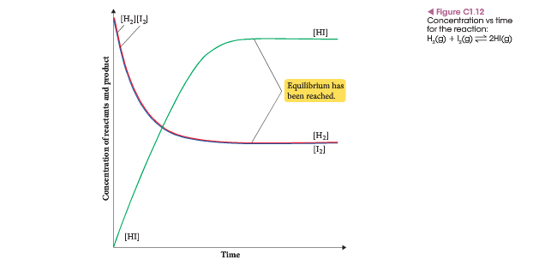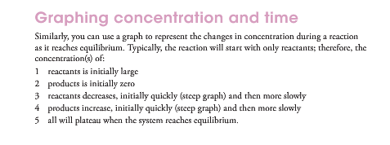

Comparison on How to Graph:

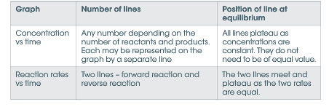

EQUILIBRIUM CONSTANT (K):

There is a mathematical relationship between the concentrations of the reactants and products. This is known as the Equilibrium Constant or K.

The Equilibrium Constant is specific for a particular reaction at a particular temperature.

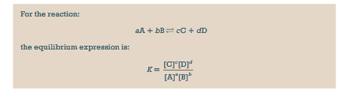

The equilibrium constant is based on the ratio of the concentration of reactants and products. Aqueous solutions and gases are included, as their concentrations fluctuate but SOLIDS AND LIQUIDS ARE NOT included.

Heterogeneous System= Substances are in more than one state. Solids and Liquids are not included.

Homogenous System= All substances are in the same state, liquids and solids are included because their relative proportions are important.

SIZE OF EQUILIBRIUM CONSTANT:

The magnitude of K can help to predict the relative concentrations of products and reactants snd therefore the position of equilibrium.

* Large K (K>1): indicates that the reaction is almost at completion, as nearly all of the reactants turn to products. Equilibrium lies to the right, as there are more products present at equilibrium.
* Small K (0<K<1): indicates that the reaction only occurs to a small extent. We say that the equilibrium lies to the left as there are more reactants.
* K is close to one: indicates there are significant concentrations of both reactants and products at equilibrium and that they are nearly equal.

YIELD: refer to how much product can be produced. This is dependant on the position of equilibrium and therefore the magnitude of the equilibrium constant. High K= High yield.

RATE: refers to how fast this yield is achieved.

CHANGES TO EQUILIBRIUM:

If the temperature, concentration, partial pressure and volume of a system changes, the ratio of the products to reactants is no longer the same and therefore not the same as the equilibrium constant. Therefore the system is no longer at equilibrium, either the forward or reverse reaction is favoured when re-established.

FORWARD REACTION: If the forward reaction is favoured, then we say that equilibrium has shifted to the right. More products produced, and products are on the right side.

REVERSE REACTION: If the reverse reaction is favoured, then the equilibrium shifts to the left due to the production of more reactants.

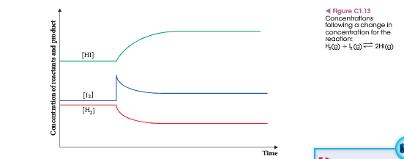CONCENTRATION: An increase in the concentration of a reaction will increase the rate of reaction due to the increased number of collisions. If the concentration of one chemical in a system at equilibrium is increased, then the rate of the reaction tht uses said chemical will increase. This will use up some of the additional chemical, reducing concentration and therefore this rate will gradually decrease. The rate of the other reaction will also increase as more of its reactants are produced. Therefore eventually the rates of the two reactions will once again become equal and equilibrium is re-established.

PARTIAL PRESSURE: The partial pressure of a gas and its concentration are related because they are both due to the number of particles in a given volume. Therefore a change in partial pressure will cause a proportional change in concentration. In gaseous state, the partial pressures of the gases can be used to indicate the concentration.

CHANGES TO VOLUME AND PRESSURE: Whenever the volume or pressure of a gaseous state is changed, the concentration of all gaseous state is altered. Thus the concentration of both reactants and products may change. Whichever concentration (reactants or products) changes the most, will have the biggest influence on the change in equilibrium.

If the volume of a system is halved, then the pressure, and therefore concentration of all the gases would double; The rate of both reactions would therefore increase. The opposite would happen if the volume is doubled.

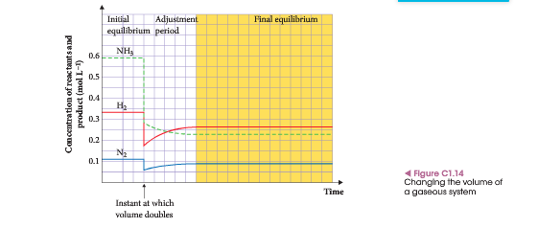

If adding or removing WATER changes the volume of a solution, then the same principle applies, as the concentrations of all aqueous substances will change.

Another situation to consider is where equal molecules of gases molecules in the reactants and products of the equation. If the volume changes in the system, the concentration of reactants and products change equally and remain equal. Therefore equilibrium has not been altered.

CHANGES TO TEMPERATURE

In a reversible reaction, the reaction in one direction will be exothermic while the reaction in the opposite direction will be endothermic.

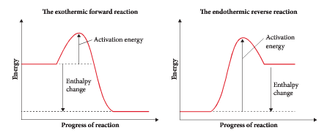

When the temperature of the system is increased, the rate of the endothermic reaction is favoured and increased. When the forward reaction is endothermic and temperature is increased, the value of k will be lower than at the original temperature due to reactant being favoured.

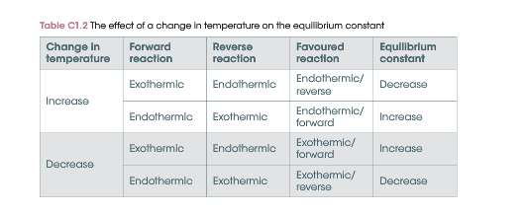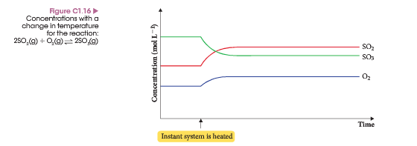A change in temperature will result in a shift in equilibrium that will affect the equilibrium constant.

ADDITION OF A CATALYST: The addition of a catalyst does not affect the position of equilibrium, only the rate at which equilibrium is achieved.

LE CHÂTELIER’S PRINCIPLE

Le Châtelier’s Principle states: If a system is at equilibrium is subjected to a change in conditions, then the system will behave in such a way so as to partially counteract the change.

The principle can be used to predict the changes that will occur following a change in concentration of chemicals, pressure, volume or temperature of a system at equilibrium.

STEPS:

1. What is the change imposed? Concentration, volume, pressure or temperature?
2. What is the opposite of the change? This is what the system will do.
3. Which reaction is favoured- forward or reverse?
4. Does equilibrium shift to left or to the right? Right= forward, left= reverse
5. What happens to the concentrations of each aqueous solution or gas?

CHANGES TO CONCENTRATION OR PARTIAL PRESSURE

* If the concentration of a reactant is increased, the system will decrease it by favouring the forward reaction, causing an increase in products.
* If the concentration of a product is decreased, the system will make ore products and equilibrium is shifted to the right (forward reaction)
* Partial pressure of gas is proportional to its concentration in gaseous state.

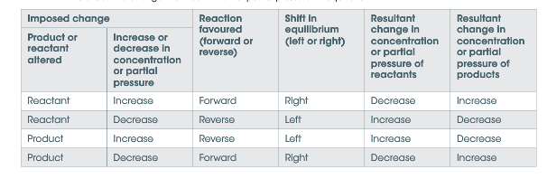

CHANGES TO VOLUME

If the volume is changed, the concentrations will all be altered.

* The reaction that will produce more molecules will increase the concentration or pressure
* The reaction that uses more molecules will decrease the concentration or pressure.
* If volume is decreased, the pressure increases.

CHANGES TO TEMPERATURE

* If temperature is increased, the endothermic reaction will be favoured
* If the temperature is decreased, the exothermic reaction will be favoured.

GRAPHING CHANGES

GRAPHING CHANGES TO CONCENTRATION OR PARTIAL PRESSURE

* When there is a change, there will be a sudden increase or decrease in the substance(s) added or removed.
* The concentration of all the species will then change more gradually until the concentrations are constant and equilibrium is re-established.

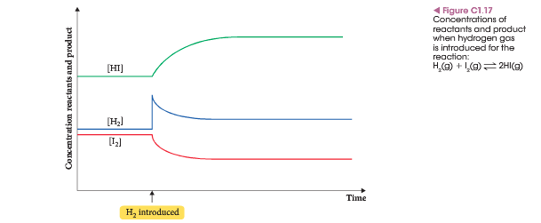GRAPHING CHANGES TO VOLUME OR PRESSURE

* If the volume of a gas is altered, then the concentrations of all gases will change
* This is shown by a sudden increase or decrease
* If water is added, the concentrations of all aqueous solutions will decrease

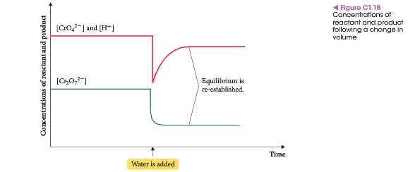

GRAPHING CHANGES IN TEMPERATURE

* When the temperature of a system at equilibrium is altered, there are no sudden initial changes in concentration.
* One reaction will be favoured as equilibrium is re-established
* The concentrations will gradually change as the system counteracts the change

Endothermic = + Enthalpy Exothermic = - Enthalpy

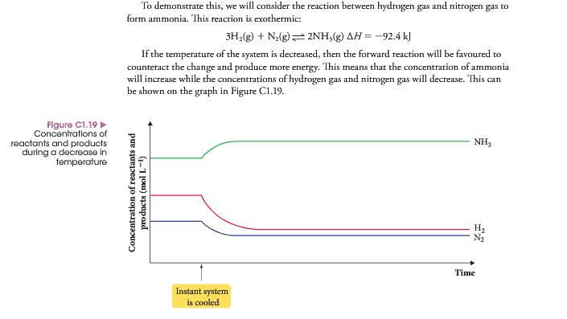

SUMMARY OF IDENTIFIABLE CHANGES ON A GRAPH

